*Samsung mobile*

*SAMSUNG GALAXY A12*

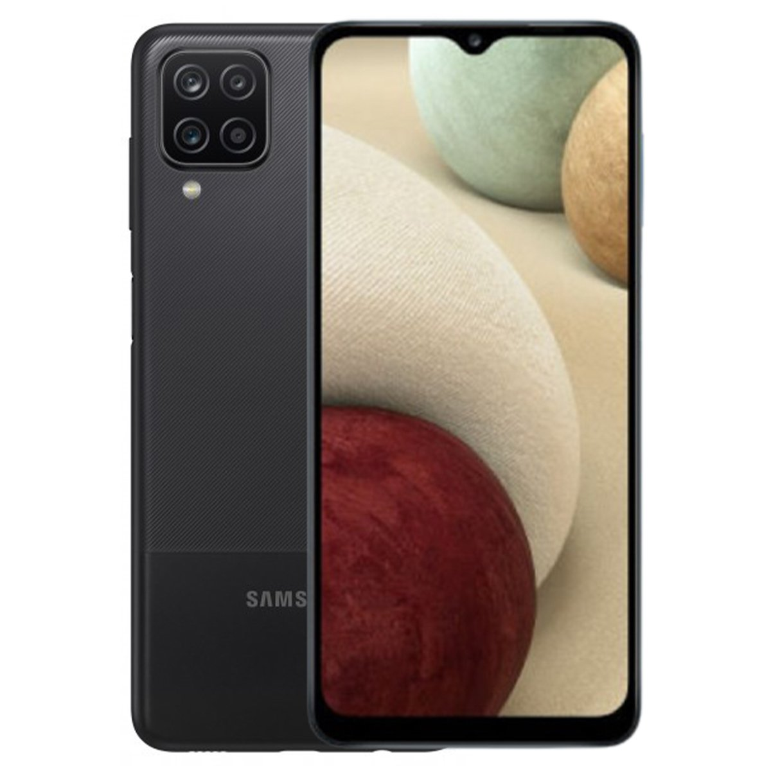

**Samsung Galaxy A12** ; Size, 6.5 inches, 102.0 cm2 (~82.1% screen-to-body ratio) ; Resolution, 720 x 1600 pixels, 20:9 ratio (~270 ppi density) ; OS, Android 10, ...

**PRICE /39,499.00 PRK**